Texoma Council of Governments
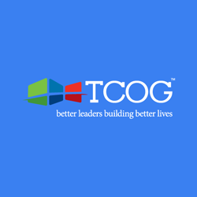

Relatives as Parents Support Group (Aging & Caregiver Services)
FREE
1st Monday of the Month
10:00am-11:00am
Phone: (903) 893-2161
Email: info@texoma.cog.tx.us
Website: https://www.tcog.com

