FREE Car Seat Program
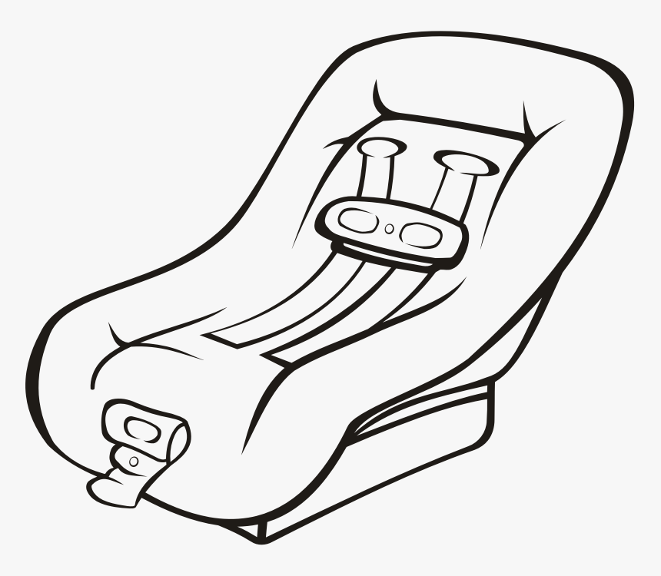
Low income to qualify
Call for Appointment
Sherman: (903) 868-9290
Fannin (903) 737-9292

